**PASSPORT MANAGEMENT SYSTEM**

**CLASS DIAGRAM:**

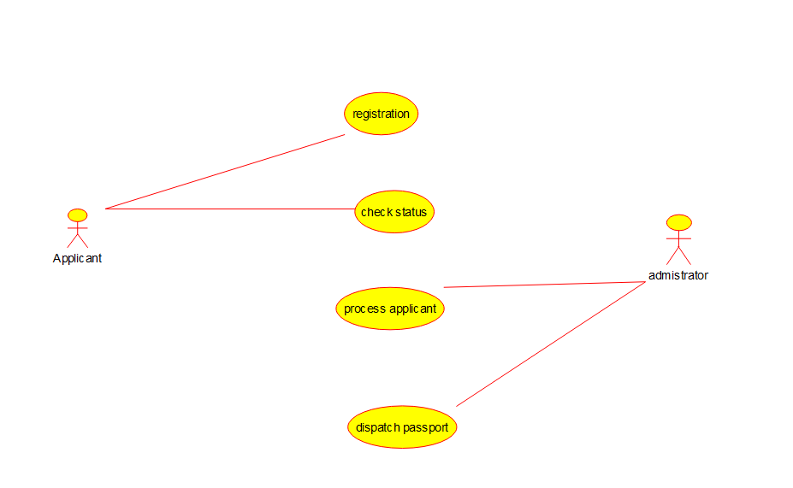

**ACTIVITY DIAGRAM**

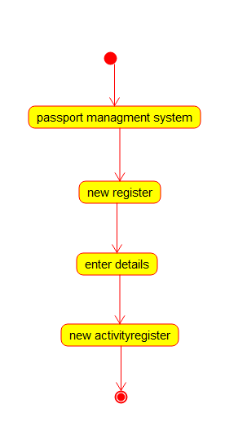

**Class diagram**

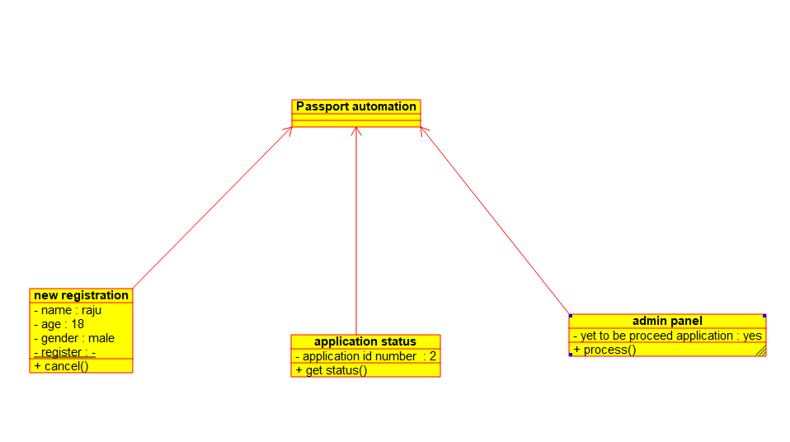

**Sequence diagram**

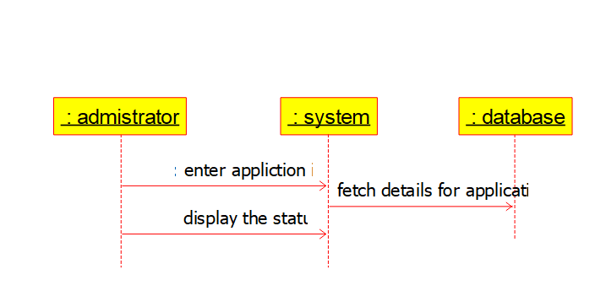

**Collaboration diagram**

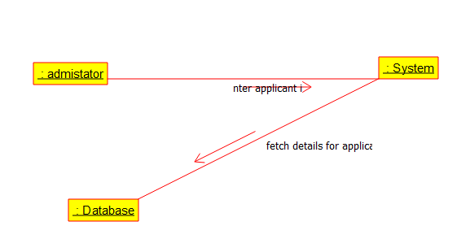

**Package diagram**

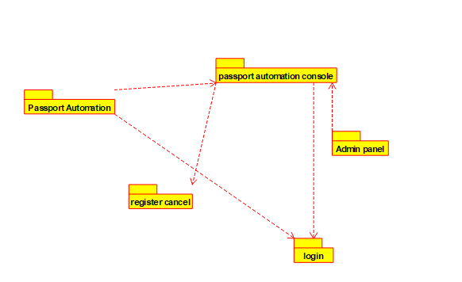

**Deployment diagram**

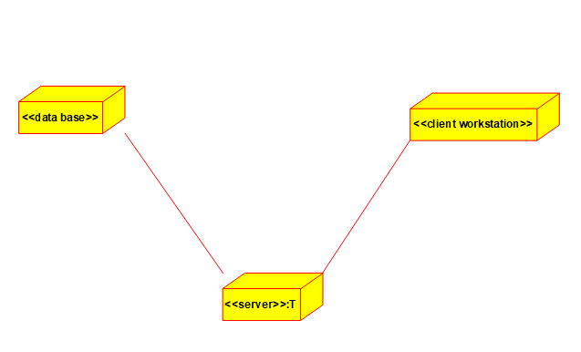

**Component diagram**

